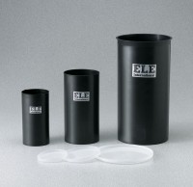 | Plastic Cylinder Mould 6" x 12"  Code: 34-5294  Product Group: Plastic Cylinder Moulds  (152 x 305 mm). Carton of 20.

Standards
ASTM C39, ASTM C470, AASHTO M205

Specification
Construction | Single unit molded polypropylene
Inner Dimensions | 6" diam x 12" h (152 x 305 mm)
Weights | Net 15 lbs (6.8 kg)

