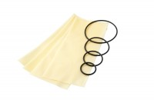 | Rubber Membrane 100mm/4 Inch Diameter. Pack of 10  Code: 25-7621  Product Group: Rubber Membranes, Rubber Membranes, Tri-Flex 2 Permeability Test Cell  100 mm/4 Inch diameter rubber membrane (pack of 10).

Standards
ASTM D2850, ASTM D4767, ASTM D5084, AASHTO T296, AASHTO T297, ASTM D7181

