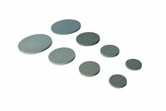 | Porous Disc 38mm/1.5 Inch Diameter. Pack of 2.  Code: 25-5181  Product Group: Accessories for CU/CU effective stress, Porous Stones  Porous disc For 38 mm/1.5 Inch samples (Pack Of 2).

