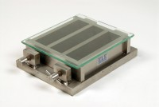 | Three-gang Mould  Code: 39-1100  Product Group: Moulding of Prisms  For 40.1 x 40 x 160 mm mortar prisms. This mould is manufactured to a very high specification. Supplied with glass plate.

Further Information
**NOT AVAILABLE FOR SALE IN THE USA**

Spares/Consumables
 | Glass Plate  Code: 39-1100/10
Mortar Sand
Code: 39-1170

