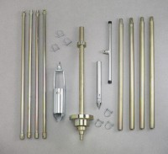 | Portable Dynamic Cone Penetrometer  Code: 29-5505  Product Group: Portable Dynamic Cone Penetrometer/Auger Set  Consists of sliding drive hammer assembly, cone penetrometer point attached to a 12" (305 mm) rod, four 30" (762 mm) "E" drill rod extensions.

Specification
Auger Head | 3-1/4” (82.6 mm) bucket diam. 4” (102 mm) blade diam.
Tee Handle | not included
Extensions | not included
Slide Hammer | 15 lb. circular disc with 20” (508 mm) free fall.
Hammer Extensions | Four 30” (762 mm) E Drill rods.
Penetrometer Cone | 30°.
Weight | Net 78 lbs. (35 .4 kg).

Spares/Consumables
 | 3-1/4" Auger Head  Code: 23-1400/10
30" Drill Rod with Extensions
Code: 29-5500/12
Auger Extensions 36"
Code: 23-1400/12
Cone Penetrometer Point
Code: 29-5500/11
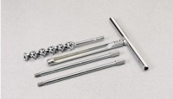 | Connector Pin  Code: 23-1400/13
Sliding Drive Hammer Assembly
Code: 29-5500/10
Tee Handle
Code: 23-1400/11

