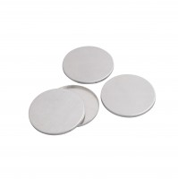 | Aluminium Petri Dishes Pack of 25.  Code: 422-560  Product Group: Microbiological starter packs and consumables  Reusable pack of 25.

