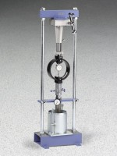 | Laboratory CBR, Hand Operated (Metric)  Code: 2421E  Product Group: Laboratory CBR, Hand-Operated  Set includes:  EI24-9345. CBR Loading Press x 1  EI78-0860. Proving Ring, 11,200 lb. x 1  EI88-4110. Penetration Dial Indicator x 1  EI24-9229. CBR Molds x 4  EI24-9238. Spacer Disc x 1  EI24-9240. Filter Screens x 4  EI24-9250.Box, Filter Paper x 1  EI24-9260. Swell Plates x 2  EI24-9262. Tripod Attachment x 1  EI88-4110. Dial Indicator x 1  EI24-9245. Surcharge Weights x 4  EI24-9244. Slotted Surcharge Weights x 4  EI24-9063. Compaction Hammer x 1  EI24-9010. Straightedge x 1  EI24-9236. Cutting Edge x 1

Standards
ASTM D1883, AASHTO T193

