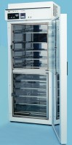 | Humidity Cabinet to En196 320 Litre Capacity  Code: 39-1300/06  Product Group: Humidity Cabinet BS EN  For 220 - 240 V AC, 60 Hz, 1 ph.

Further Information
**NOT AVAILABLE FOR SALE IN THE USA**
10 Reinforced Shelves and Circular Chart Recorder

Spares/Consumables
 | Replacement Circular Charts  Code: 39-1300/10

