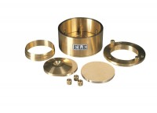 | Cutting Ring 50mm Cell.  Code: 25-0458  Product Group: High pressure application consolidation cells and accessories, Fixed Ring Consolidation

