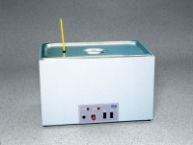 | Circulating Water Bath  Code: 45-6471/02  Product Group: Circulating Water Bath

Standards
ASTM D6927, AASHTO T245

Further Information
110vAC, 60 Hz, 1ø.

Specification
Capacity | Up to twelve 4â (101.6 mm) diam. Marshall specimens.
Heaters | Thermostatically controlled.
Circulator | Magnetic type.
Range | Ambient to 150Â°F (65.5Â°C); accurate to  within +/- 1Â°F (+/- 1Â°C).
Construction | Insulated stainless steel tank with painted  steel exterior.
Weight | Net 47 lbs. (21 .4 kg).

