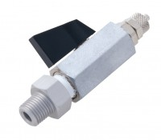 | Valve No Volume Change 1/4 Inch BSp Fitted with 6 mm Connector and Integral Sealing Ring.  Code: 25-4520  Product Group: General Cell Accessories, Accessories for CU/CU effective stress

Standards
ASTM D2850, ASTM D4767, ASTM D7181, AASHTO T296, AASHTO T297

