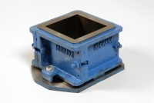 | 200mm Cube Mould Clamp Type. Cast Iron Construction. Stamped Mould Sections. EN Compliant.  Code: 34-4620  Product Group: Cube Moulds  4-part with clamp attached base plate.

Further Information
**NOT AVAILABLE FOR SALE IN THE USA**

