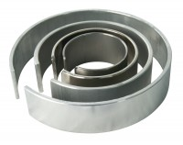 | Membrane Placing Tool 70mm/2.8 Inch Diameter.  Code: 25-6470  Product Group: Membrane Placing Tools, O-Ring Placing Tools, Tri-Flex 2 One-Cell Permeability Test System  70Mm/2.8 Inch Diameter Membrane Placing Tool.

