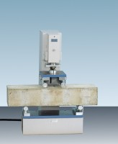 | 100kN Flexural (Beams) Frame. Supplied Without Specimen Bearers and Fitting Kit.  Code: 37-6130  Product Group: Flexural Testing for Beams  • Open sided for ease of specimen loading  • Meets EN 12390-5, 1521, 13161, 772-6 and ASTM C78 for standard section beams  • Optional ball seating assembly  This rigidly constructed, open sided frame is suitable for testing 100 mm and 150 mm square-section beams. The frame supports a hydraulic ram and upper sub-platen assembly incorporating a spherical seating. The upper and lower sub-platens will accept various specimen loading bearers, which are supplied separately.

Further Information
**Not available for sale in the USA**

