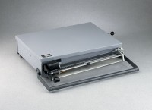 | Portable Bench Beam Scale - 301 lbs Capacity  Code: 88-1520  Product Group: Portable Bench Beam Scales

Specification
Capacity | 301 lbs.
Beams | 295 lb x 5 lb; 5 lb x 1 oz; 1 lb x 0.1 lb.
Tare | On fourth bar.
Platform | 21 .75â w. X 16.25 â d. (552 x 413 mm).
Locking Device | Lever type.
Carrying Handle | Built-in.
Weights | Net 38 lbs. (17.2 kg).

