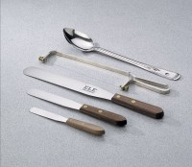 | Sampling Spoon  Code: 88-7700  Product Group: Sampling Spoon

Specification
Construction | Heavy-gauge stainless steel.
Length | Approx. 12â (305 mm).
Weight | Net 4 oz. (113 g).

