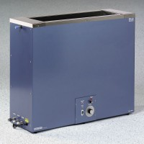 | Hydrometer Jar Bath 220vAC  Code: 24-4867/01  Product Group: Hydrometer Jar Bath

Standards
ASTM D422, AASHTO T88

Further Information
220vAC, 50/60 Hz, 1ø.

Specification
Capacity | 8 hydrometer jars.
Construction | Stainless steel tank; enamel finish exterior.
Jar Support | Stainless steel grid.
Temperature Range | Ambient to 60Â°C (14 0Â°F).
Sensitivity | Â±0.2Â°C at 20Â°C (68Â°F).
Circulating System | Drive pump with motor.
Heating System | Immersion type; 700 watt heater in stainless steel  mixing chamber.
Plumbing Ports | Overflow; Drain; Inflow and outflow for cooling  system.
Inside Dimensions | 37â w x 8â d x 16â h (939 x 203 x406 mm)
Outside Dimensions | 48 â w x 11 â d x 19â h (1,219 x 279 x 483 mm)
Weight | Net 90 lbs. (41 kg).

