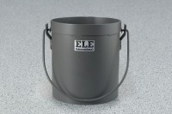 | Yield Buckets 1/10 cu. Ft. Capacity  Code: 34-2860  Product Group: Yield Buckets, Yield Buckets  1/10 cu. Ft. Capacity

Standards
ASTM C138, AASHTO T121

Specification
Construction | Heavy-duty steel; welded connecting edges; water tight.
Handle | Bail-type with welded lugs.
Dimensions | 6â (152 mm) i.d. x 6.1â (154 .9 mm) inside h.
Weights | Net 6 lbs. (2.7 kg).

