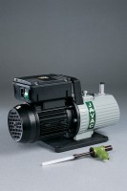 | Filter Pump  Code: 82-7700  Product Group: Vacuum Pumps

Further Information
**NOT AVAILABLE FOR SALE IN THE USA**

Specification
Construction | Moulded plastic body
Ultimate vacuum | 12 to 15 torr (12 to 15 mm Hg)
Water supply pressure required | 14 kPa
Weight | 200 g

