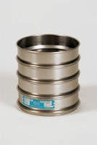 | 200mm Dia BS Sieve 1.40mm Stainless Steel Mesh.  Code: 79-0250  Product Group: 200mm Diameter BS Sieves, 200mm Diameter BS Sieves, 200mm Diameter BS Sieves

Standards
BS 410, ISO 3310

Further Information
**NOT AVAILABLE FOR SALE IN THE USA**

