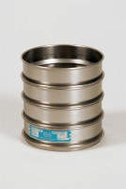 | 8 Inch Dia Lid.  Code: 79-5400  Product Group: Sieve Lids and Receivers ASTM, U.S Standard Testing Sieves, 8" Diameter ASTM Sieves, 8" Diameter ASTM Sieves, 8" Diameter ASTM Sieves

Standards
ASTM E11

