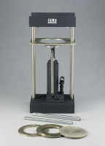 | Asphalt Sample Ejector  Code: 45-6480  Product Group: Asphalt Sample Ejector

Standards
ASTM D6926, AASHTO T245

Further Information
For 4" diameter asphalt specimens.

Specification
Capacity | 4â (101.6 mm) l.
Pushing Force | 6,000 lbf. (26.7 kN).
Jack | Hydraulic; hand-operated; 7â  (178 mm) stroke; spring return.
Construction | All metal; plated extrusion plates and  piston discs; painted finish on housing  and pump.
Dimensions | 10-3/8â w. x 8â d. x 23-3/8â h. (264 x 203 x 594 mm).
Weight | Net 60 lbs. (27 kg).

