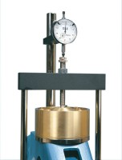 | Vertical Dial Indicator, English  Code: 25-0445  Product Group: Direct/Residual Shear Apparatus  0.5" range x 0.0001" graduations.

