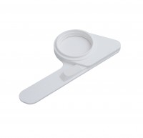 | Pad Dispenser.  Code: 422-515  Product Group: Microbiological starter packs and consumables

Spares/Consumables
 | Coliform Starter Pack. Sufficient for 200 Tests  Code: 422-010

