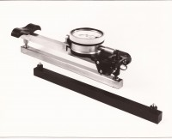 | 200mm "Demec" Mechanical Strain Gauge  Code: 35-2846  Product Group: Strain Gauge  This gauge is ideal for monitoring cracks and strains in a number of structure types.

Standards
BS 1881-206

