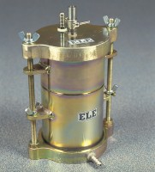 | Compaction Permeameter.  Code: 25-0607  Product Group: Compaction Permeameter  101.6 mm

Specification
Mould | Machined seamless steel tubing, plated
Capacity | 101.6 x 116.4 mm (inside dia x h) 1/30 ft3
Collar | 50.8 mm high, machined
Top | Overflow valve assembly and water  connection
Base | Cast aluminum, with inlet/outlet fitting
Porous stone | 101.6 x 12.7 mm (diameter x thickness)
Weights | 5.4 kg

