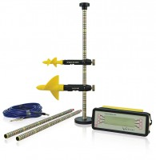 | Large Current Flow Meter Wading Set for Velocities 0.03 to 10 M/S.  Code: 520-260  Product Group: Flow meters  Consisting of current meter, revolution counter, wading rods, base and knob, 3 metres wading cable. All packed into carrying case.

Further Information
Case dimensions: 850 x 180 x 220 mm

