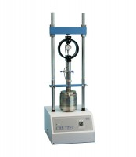 | CBR Test Accessory Set English  Code: 24-9175  Product Group: Versa-Loader  Includes lower platen, penetration piston assembly, dial indicator with 1.0” range 10,000 lb capacity proving ring and mounting hardware.

Standards
ASTM D1883, AASHTO T193

