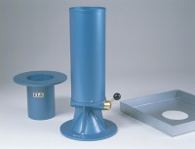 | Metal Tray 300mm Sq. X 40mm Deep with A 100mm Dia Hole.  Code: 29-4040  Product Group: Sand Replacement

Standards
BS 1377, BS 1924

