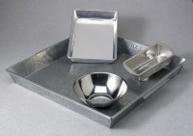 | Mixing Pan - Rectangular Tin  Code: 88-7100  Product Group: Mixing Pans and Bowls  Tin; 8-1/2” x 4-1/2” x 2-3/4” (216 x 114 x 70 mm).

