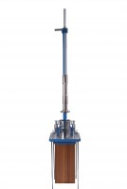 | Compaction Hammer  Code: 45-6460  Product Group: Manual Compaction, Stability Compaction Hammer  Satisfies BS 598. The hammer has a 4535 g sliding weight with a free fall of 457 mm.

Standards
EN 12697-30, ASTM D6926, AASHTO T245

Specification
Tamping Face | 3-7/8” (98 mm) diam.
Hammer | 10 lb. (4.54 kg).
Drop | 18” (457 mm).
Construction | Machined steel; cast aluminum handle.
Weight | Net 16 lbs. (7.2 kg).

