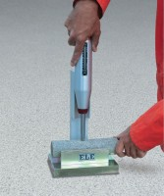 | Rock Classification Hammer  Code: 77-0470  Product Group: Rock Classification Hammer

Specification
Plunger | Applies pressure for hammer rebound.
Body | Aluminum; with indicator scale.
Rubbing Stone | Prepares test surface.
Accuracy | Within 15 %.
Weight | Net 3 lbs. (1.4 kg).

