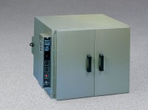 | Bench Oven - Hydraulic Thermostat - 7 cu. ft. capacity - 230vAC  Code: 88-0130/01  Product Group: Bench Ovens  230vAC, 50/60 Hz, 1ø.

