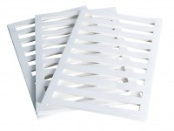 | Filter Paper Drain 38mm/1.5 Inch Diameter. Pack of 50.  Code: 25-5200  Product Group: Accessories for CU/CU effective stress, Filter Paper Drains  Filter paper drain 38 mm diameter (Pack Of 50).

