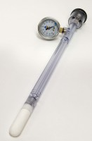 | Jet Fill Tensiometer 460 mm  Code: 514-037  Product Group: Tensiometers  460mm Long

Further Information
Requires Part No 514-034

