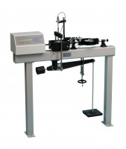 | Digital Direct/Residual Shear Apparatus Complete with Lever Loading Assembly. 110-120V 50/60Hz 1Ph.  Code: 26-2114/02  Product Group: Direct/Residual Shear Apparatus, Direct/Residual Shear Apparatus  • Microprocessor control  • Large on-board LCD screen display  • Direct entry via touch sensitive keyboard  • Rapid approach and return to start datum  • Fully variable speed, 0.00001 to 9.99999 mm/minute  • Accepts specimens up to 100 mm square  The ELE Direct Shear Apparatus accepts specimens 60 mm, 100 mm square or 2.5 inches in diameter. The use of a microprocessor controlled drive system and keyboard entry gives the apparatus a wide range of features that include pause and speed reset during test, RS 232C interface, operator programming of speed and control functions, self test diagnostics and many other features. A return to start datum provides a positive means of reversing the shearbox when either preparing for a new test or continuing with residual testing procedures.  Safety forward/reverse travel limit switches are fitted as standard and monitored through the electronics system control.  The electronics are housed in a modern moulded shroud, which includes a large LCD display and keyboard entry. The apparatus is enclosed in a robustly constructed case, has been designed for floor mounting and is supplied complete with carriage, loading hanger and 10:1 lever loading device

Standards
ASTM D3080, AASHTO T236

Further Information
for 110 - 120 V AC, 50 - 60 Hz, 1 ph.

Specification
Sample Size | Accepts either 2.42 ”, 2.5” diam.; 60 mm square samples using accessory shear box assemblies, not included.
Speed Range | Variable in either English or Metric units between 0.000001”  (0.00001 mm) to 0.399999” (9.99999 mm) per minute.
Shear Force | 1,000 lbf. (4.5 kN) maximum.
Vertical Load | 2,200 lbf. (1,000 kN) using 10:1 lever ratio.
Dimensions | 44.7” l. x 12 .6” w. x 49.6” h. (1,135 x 320 x 1,260 mm).
Weight | Net 181 lbs. (82 kg).

Spares/Consumables
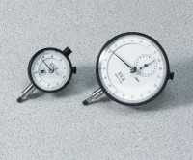 | Dial Indicator - 1.0" Range  Code: 88-4100

