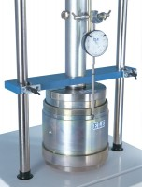 | CBR Penetration Piston Assembly  Code: 24-9179  Product Group: CBR-Test 50 Machine  For use on CBR-test.

Standards
ASTM D1883, AASHTO T193

