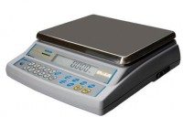 | Electronic Balance - 16 000 g x 0.5 g  Code: 78-5477/01  Product Group: Electronic Balances

Further Information
**Not available for sale in the USA**

Specification
Capacity resolution | 16000 g x 0.5 g
Pan size | 225 x 300 mm
Mains and battery | Yes
Dimensions (l x w x h) | 340 x 320 125 mm
Weight | 4 kg

