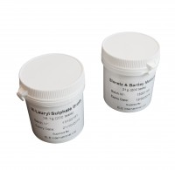 | Membrane Lauryl Sulphate Medium 38.1 Gram Pack. Sufficient for 200 Tests.  Code: 422-110  Product Group: Microbiological starter packs and consumables  38.1 grams to make approximately 500 ml medium (200 tests).

Spares/Consumables
 | Coliform Starter Pack. Sufficient for 200 Tests  Code: 422-010

