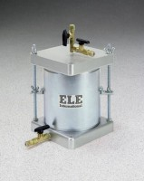 | Compaction Permeameter 6"  Code: 25-0619  Product Group: Compaction Permeameters

Standards
ASTM D5856

Specification
Mould | Machined seamless steel tubing; plated.
Capacity | 0.1145 cu. ft.; 6â i.d. x 7â h. (152 .4 x 177.8 mm).
Collar | 2â h. (50.8 mm); machined seamless steel tubing; fits either end of mold; plated.
Top | Cast aluminum; with overflow valve  assembly and water connection.
Base | Cast aluminum; with inlet/outlet fitting.
Porous Stone | 5-15 /16â diam. x 1/2â thick (15 0.8 x 12 .7 mm).  50-70 permeability rating; 225 micron,  average pore size.
Weights | Net 24 lbs. (10.9 kg).

Spares/Consumables
 | Porous Stone for 25-0619  Code: T-324

