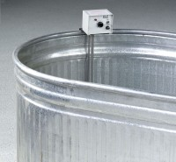 | Curing Tank Heater  Code: 34-6768/02  Product Group: Curing Tank Heaters

Further Information
110vAC, 50/60 Hz, 1ø.

Specification
Construction | Thermostatically controlled with solid state circuitry for warming up to 160F (71C); mounted on aluminum base, 22 1/2" (572 mm) overall length. For use on tanks where temperature does not fall below 55F (13C).
Weights. | Net 5 lbs. (2.3 kg).

