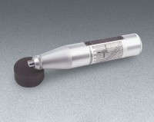 | Concrete Test Hammer - English  Code: 35-1475  Product Group: Concrete Test Hammer  With English Calibration Curves

Standards
ASTM C805

Specification
Body | Includes indicator scale, calibration curves.
Calibration Curves | Rebound number vs. compressive strength.
Rubbing Stone | Prepares test surface.
Accuracy | Within 15 %.
Carrying Case | Plastic.
Weight | Net 3 lbs. (1.4 kg).

Spares/Consumables
 | Rubbing Stone  Code: 35-1475/10

