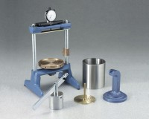 | Expansion Pressure Frame  Code: 45-7580/10  Product Group: Expansion Pressure Device  With Turntable, Stem and Plate. Net Wt. 19 lbs. (8.6 kg).

