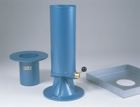 | 150mm Calibrating Container 150mm Id X Deep with 250mm Dia Rim.  Code: 29-4120  Product Group: Sand Replacement

Standards
BS 1377, BS 1924

