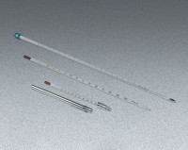 | Glass Laboratory Thermometer - 0° to 300°F x 2.0°; 12” (305 mm) l.  Code: 88-4494  Product Group: Glass Laboratory Thermometers

