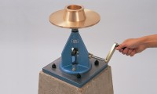 | Flow Table  Code: 38-6000  Product Group: Flow and Workability of Mortar Lime  Manufactured from cast bronze as specified in BS and ASTM C230. Complete with Tripod and Baseplate.

Standards
BS 4551-1, BS 3892-1, ASTM C230

Further Information
**NOT AVAILABLE FOR SALE IN THE USA**

