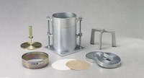 | 5Lb (2.27Kg) Split Surcharge Weight.  Code: 24-9244  Product Group: Surcharge Weights, ASTM/AASHTO CBR mould and accessories

Specification
Construction | Machined steel.
Finish | Plated.

