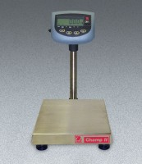 | Champ II Series Bench Scale - 60 lb / 30 kg Capacity  Code: 88-1302/02  Product Group: Champ II Series Bench Scales  60 lb./30 kg capacity. 120vAC, 50/60 Hz.

Further Information
100-240V, 50/60 Hz.

Specification
Capacity | 60 lb. x 0.01 lb. or 30 kg x 0.005 kg.
Platform Size | 12 â x 14 â (30.5 x 35 .5 cm).
Power | 9 vDC/500 mA AC adaptor (included)  or six âCâ batteries (not included).
Weights | Net 24 lbs. (11 kg).

