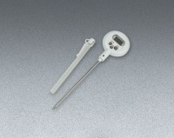 | Digital Pocket Thermometer  Code: 88-4434  Product Group: Digital Pocket Thermometers  Fahrenheit scale and Celsius scale.

Standards
ASTM D854

Specification
Range | -58Â° to +392Â°F or -50Â° to 200Â°C.
Resolution | 0.1Â°F or 0. 1Â°C.
Weight | 5 oz. (142 g).

