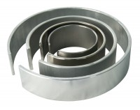 | Membrane Placing Tool 50mm Diameter.  Code: 25-5470  Product Group: Membrane Placing Tools, O-Ring Placing Tools  50 mm Diameter Membrance Placing Tool.

